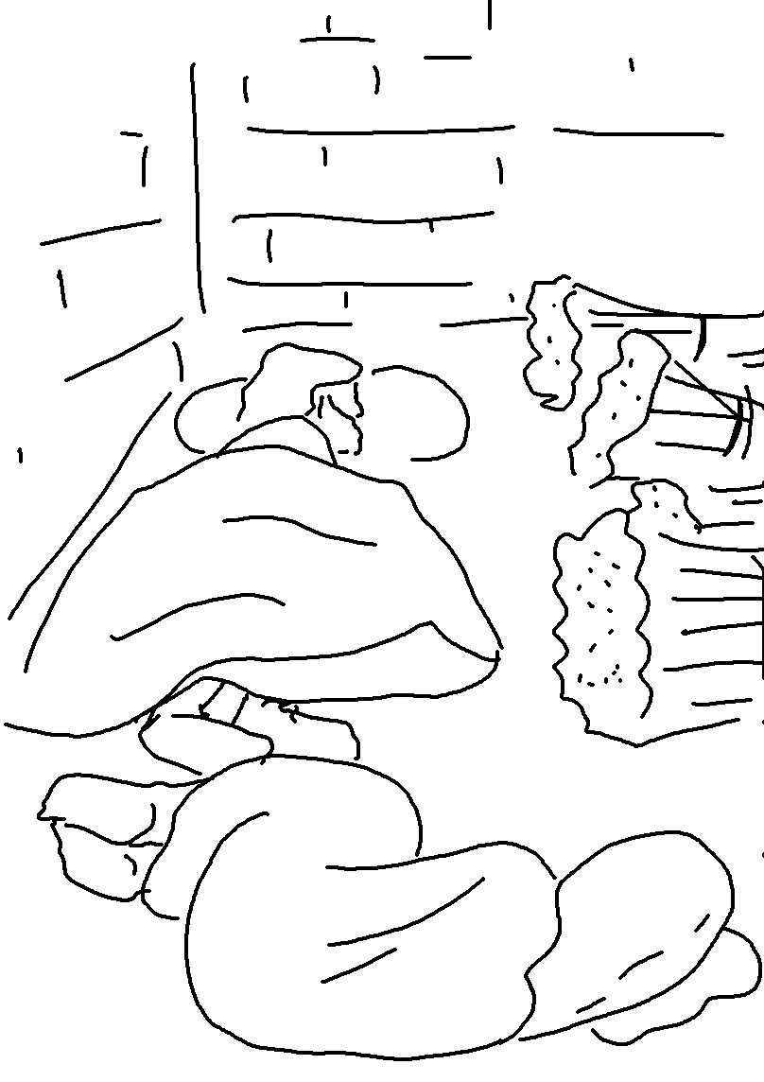
Your people will be my people, and your
_ _ _ will be my _ _ _. Ruth 1:16_{NLT}

